CS-110 Final Project

A Game of Blackjack

Brandon Donato and Devon Randall

Lab Section B-57

This GUI will project a series of buttons for the user to interact with while a display is shown to depict the game of blackjack that is occurring. This GUI is best for those who have prior experience with the game of Blackjack.

I. The Opening Screen

When the user first runs the program, two windows appear. One window displays the typical green background of a playing card table and the actual playing cards each player has. The other window that pops up is a window that displays the buttons to press in order to play the game. This window also displays the totals of each hand for both the player and the computer dealer.

II. Playing the Game

The user can now play the game of Blackjack however they’d like. They can choose to keep adding cards to their hand and lose, or try and beat the computer dealer. The dealer is programmed to stop adding cards at a value of 17, similarly to the dealers in casinos. Once a game has ended, a label will come across the graphics window stating that the player has either won or lost against the computer.

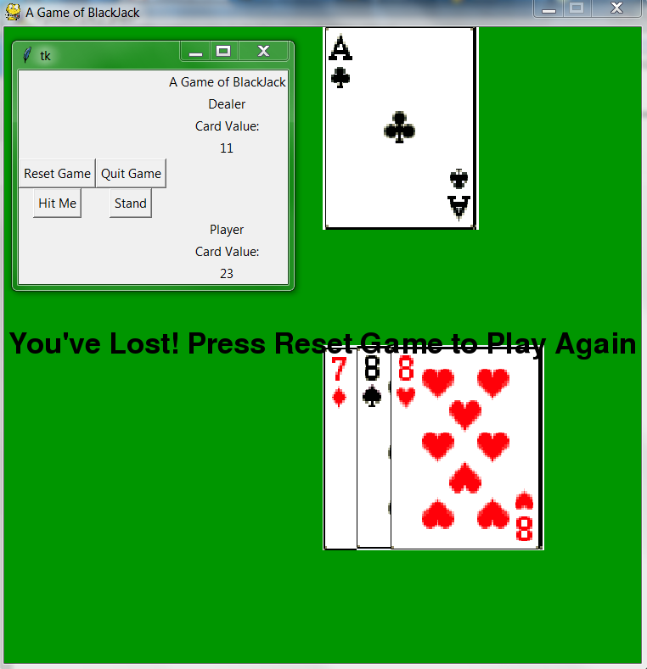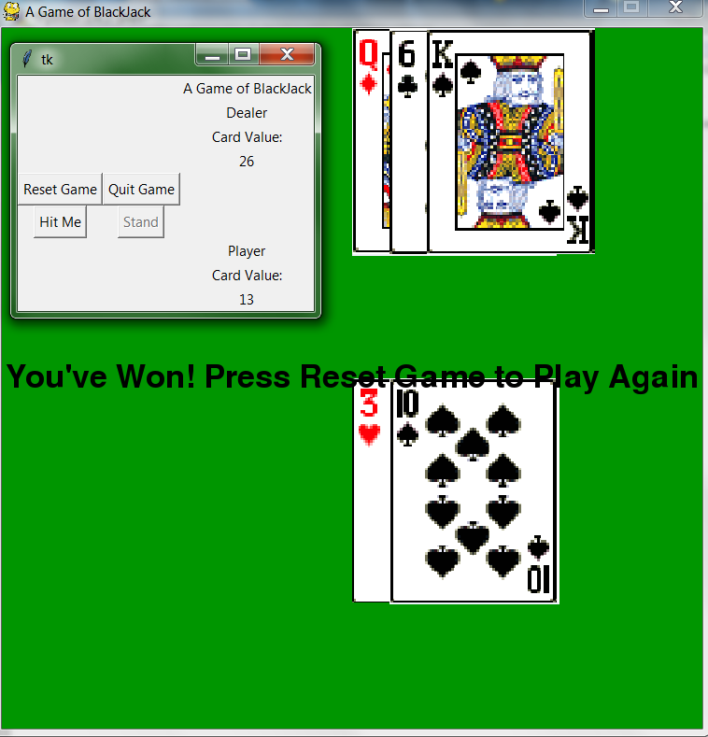

Pressing the reset game button resets the cards in the player’s hand and those in the dealer’s hand and essentially starts a new game of Blackjack.

If you don’t wish to play, pressing the quit game button will close the graphics window, thus ending the session.